

**Name of the Application**

July 10, 2017

|  |  |
| --- | --- |
| **Document Id:** | 1.1 |
| **Document Name:** | Scope Document – Prepayment Automation Tool |
| **Publication Date:** | 10/7/2017 |
| **Latest Revision Date:** |  |
| **Prepared By:** | Swapnil Kulkarni |

|  |  |  |  |  |
| --- | --- | --- | --- | --- |
| **Version** | **Date** | **Change Mode**  **(C/A/M/D)** | **Brief description of change** | **Prepared/ Revised by** |
|  |  |  |  |  |
|  |  |  |  |  |
|  |  |  |  |  |
|  |  |  |  |  |

C – Created, A – Added, M – Modified, D – Deleted

**Table of Contents**

Table of Contents 3

1. Business Requirements 4

1.1. Purpose of the Document 4

1.2. Overview 4

1.3. Current Software Applications 4

1.4. Business Objectives 4

2. Visions of the Solutions 5

2.1. Major Features 5

2.2. Proposed Solutions 5

3. Scope & Limitations 6

3.1. Scope of Initial Release 6

3.2. Limitations & Exclusions 6

4. Stakeholders 7

5. Appendix 1

5.1. 1

6. Approval Signature Page 2

# Business Requirements

## Purpose of the Document

The purpose of this document is to detail the functional design approach for “**APP**. This will be a web based application as a part of WNS SOX process which will have details of all the SOX checklist & Signoff process in WNS. It is expected the following groups of people will use this document:

* Business Sponsor and stakeholders will be expected to agree the requirements as stated within this document will meet their need.
* Solution Architects and Developers will be expected to agree to be able to deliver the requirements as stated within this document.
* Testers will base their test strategy and test cases on this document.

## Overview

Prepayments are amounts paid for by the business in advance of the goods or services being received for a future period.

Therefore, prepaid expense must be not be shown as expense in the accounting period in which it is paid but instead it must be presented as such in the subsequent accounting periods in which the services in respect of the prepaid expense have been performed.

At the end of an invoice specified period. The Prepaid expense account balance should be 0.

The prepayment process applies where we have paid for services with Net Value £5000.00+

## Current Software Applications

The following are the application:

|  |  |  |
| --- | --- | --- |
| **Application** | **Name of Application** | **Tasks it is used for** |
| 1 | Excel | Calculation, Formatting reports |
| 2 | Access | To store the database and fetch the records as per the given query. |

## Business Objectives

* Every month Expenses Management team process approx.____ prepayment invoices
* Prepayment Invoice updating in prepayment schedule, prepayment invoice allocation, Prepayment release JEs done manually
* Workings of the JEs are manual as the details have to be collated.
* Post preparation of journal entry, review done to ensure overall accuracy of journals.

# Visions of the Solutions

## Major Features

**Benefits:**

* Automated JE Preparation
* Assists in meeting TAT during crunch period
* Standardized JE descriptions
* No rework as accurate JEs are being prepared
* Eliminates the need for manual review

**Preventive Controls:**

Validation of entire JE to ensure correctness of critical inputs and prevent financial risks/errors involved in JE preparation such as:

* + GL period
  + Currency
  + JE amount
* Automatically balances the journals with respect to Debits & Credits

## Proposed Solutions

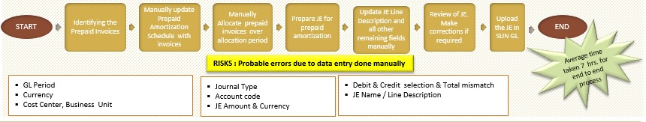

1. Manual Process

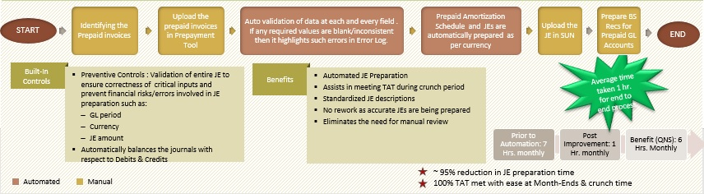

1. Automated Process

# Scope & Limitations

## Scope of Initial Release

* Input Form with validations / direct excel upload facility.
* O/P prepare prepayment schedule.
* Prepare customize reports as per the client requirement.

# Stakeholders

|  |
| --- |
| **Name of User Group SPOC: Vipul Gada** |
| **Designation: Deputy Manager – Ops** |
| **Email Address: Vipul.Gada@SompoCanopius.com** |
| **Office Contact #: -** |
| **Mobile #: 9819259978** |
|  |
| **Name of User Group Head: Neelash Sood** |
| **Designation: Sr. Group Manager – Ops** |
| **Email Address:** [**Neelash.sood@wns.com**](mailto:Neelash.sood@wns.com) |
| **Office Contact #:** |
| **Mobile #:** |

# Approval Signature Page

Deliverable Name: Vipul Gada

Version Number: 1.0

Project Name: Prepayment Automation Tool

I agree that this document represents my best understanding of the information presented within this Deliverable for this project today. Future changes in this baseline document can be made through the project’s defined change process. I realize that approved changes might require us to renegotiate the costs, resource and schedule commitments for this project.

|  |  |  |  |
| --- | --- | --- | --- |
| **Name** | **Title** | **Signature / Electronic Vote / Email** | **Date** |
| Vipul Gada | Deputy Manager - Ops | <Approver Signature> | <Date Signed/Reviewed /Emailed> |
|  |  | <Approver Signature> | <Date Signed/Reviewed /Emailed> |
|  |  | <Approver Signature> | <Date Signed/Reviewed /Emailed> |